Dublin Technological University,
Certificate, Cloud Solutions Architecture (2020)

Implementation Iteration 1

Student Name: Alan Duffin
Student ID: X00159409

Iteration 1 Tasks

Project Phase | Service / Area | Implementation Task
Design / Planning | AWS Step Functions | Design Inital Workflow / State Machine
 | AWS Lambda | Design API/Services required for Workflow / Application tasks
 | AWS DynamoDB | Design Database Schema
Build / Development | Development Environment / Toolkit | Create AWS Free Tier Account  Install Developer IDE / SDK / CLI
Build / Development | AWS DynamoDB | Build CloudFormation template.  Database Tables / Secondary Indexes
Build / Development | AWS Lambda | Build Serverless (SAM) template for customer / mortgage services.
Test |  | Test CRUD / Component Services + Database Interaction
Build / Development | AWS Step Functions | Build CloudFormation template for inital Workflow.
Test |  | Test State Transitions / Events
Build / Development | AWS SNS | Build SNS Topics and Subscriptions.
Test |  | Test Notification Events and Subscriptions

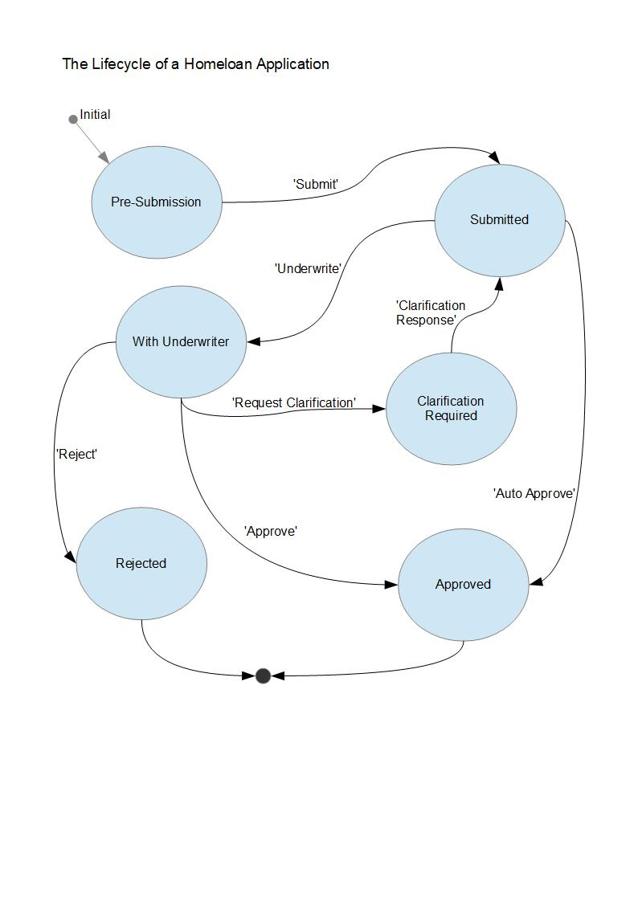
Workflow Design

The cental objective of this project is to build a solution for long – running applications that require human interaction / approval. The specific problem domain is the mortgage application / approval process. The implementation platform choosen as suitable for this type of application is the Serverless Application Model. This will involve development of a suite of AWS Lambda services that will act as tasks within the Workflow. Figure WORK.1
Figure WORK.1

Services Design

In order to build the workflow it is first necessary to put in place the substrate infrastructure / components that will be used as tasks within the workflow orchestration. The services are outlined below.

Service | URI | ACTION
Create Customer | /customer/ | PUT
Get Customer | /customer/{id} | GET
Update Customer | /customer/{id} | POST
Create Mortgage | /mortgage/ | PUT
Get Mortgage | /mortgage/{id} | GET
List Mortgages by State | /mortgage/status={statusText} | GET
Update Mortgage | /mortgage/{id} | POST
Mortgage Underwriter Notification | /mortgage/{morgageId}/underwriter/ | POST
Mortgage Branch Notification | /mortgage/{morgageId}/branch/ | POST
Mortgage Affordability Calculation | /mortgage/{morgageId}/afforability | POST
Mortgage Approval | /mortgage/{morgageId}/approve | POST
Submit Mortgage | /mortgage/{morgageId}/submit | POST

Database Schema Design

The data model for this project consists of a Customer and Mortgage. There is a Many to One relationship between customers and mortgage application objects. In order to allow users to seach mortgages that require action, it is necessary to allow query the mortgage table by status. This requires a Global Secondary Index on the Mortgage table that is indexed by the mortgageStatus attribute. See Figure DB.1

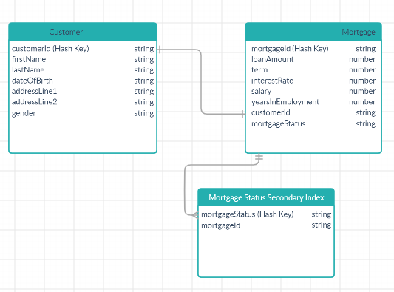
Figure DB.1

Development Environment – AWS Account

Navigate to the URL listed [1]. Follow the AWS instructions.

Development Environment – AWS CLI

Navigate to the URL listed [2]. Follow the AWS instructions.

Development Environment – AWS CLI SAM

Navigate to the URL listed [3]. Follow the AWS instructions.

Development Environment – Node JS / NPM

Navigate to the URL listed [4]. Follow the installation instructions.

Development Environment – Configure AWC CLI

Create an AWS IAM Administrator Role. Figure IAM.1
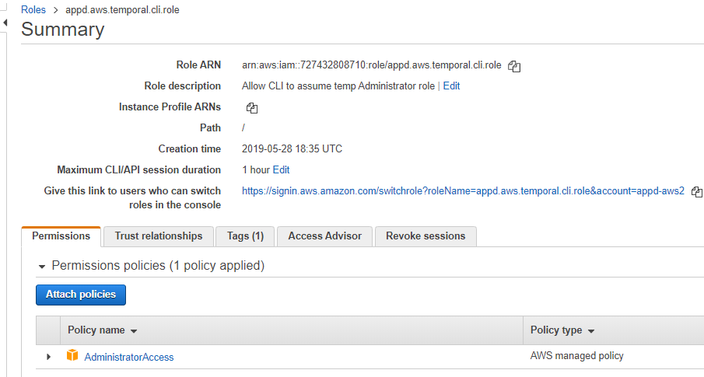Figure IAM.1

Create an AWS IAM Group for Developers. Assign Policy to allow this Group to peform temporary assume-role of the Administrator Role. Figure IAM.2
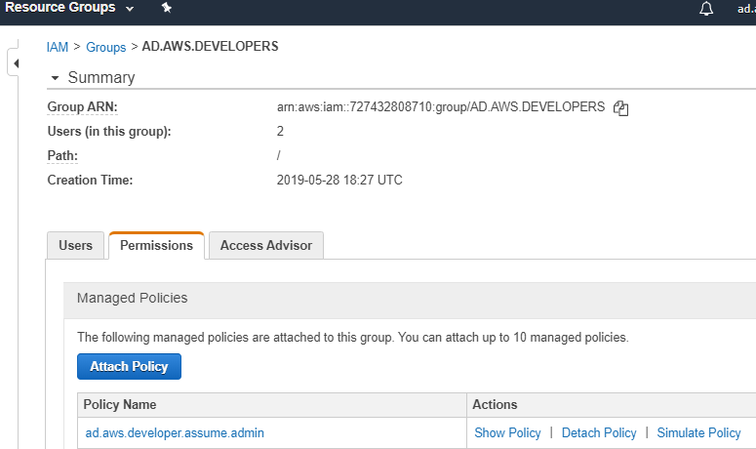Figure IAM.2
Create an IAM Developer User and Assign to the Developer Group. Figure IAM3.
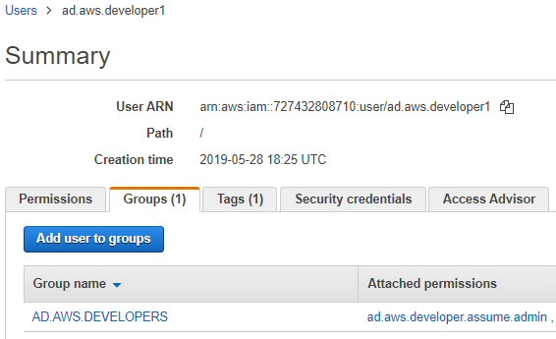
Figure IAM3.

Development Environment – Configure AWS CLI

See instructions [5]. Using the Access Key ID and Secret Access Key downloaded when creating the Developer user we now must configure the CLI.

Development Environment – Install Visual Studio Code

Navigate to the URL listed [6]. Follow the installation instructions.

Development Environment – Configure Visual Studio Code

Navigate to the URL listed [7]. Follow the installation instructions. Figure VS.1
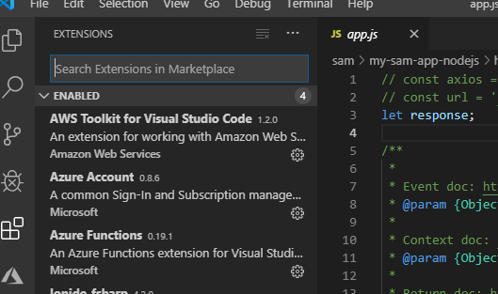
Figure VS.1

Development Environment – Deploy Sample SAM – Command Line

In order to test the toolchain I tried to deploy a sample application from the Command Line. Figure SAM.CMD.1
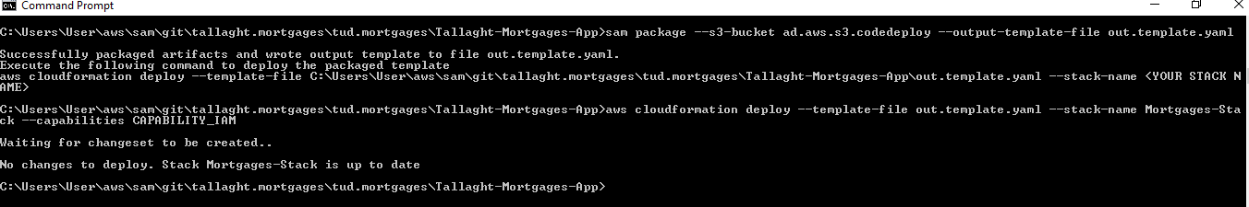
Figure SAM.CMD.1

Development Environment – Deploy Sample SAM – VS Code

In order to test the toolchain and IDE I tried to deploy a sample application from the Visual Studio Code IDE. Figure SAM.VSC.1, Figure SAM.VSC.2.
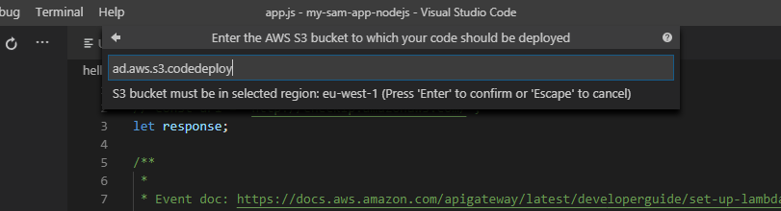
Figure SAM.VSC.1

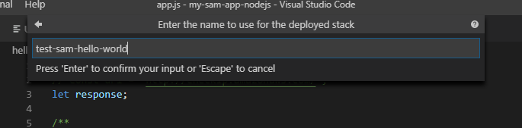
Figure SAM.VSC.2

My first attempt to deploy the code from the IDE failed. Figure SAM.VSC.3
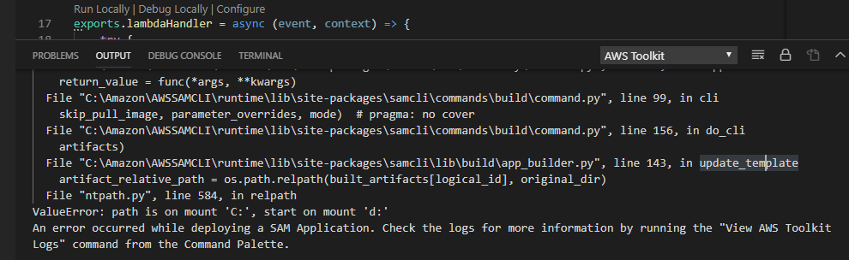
Figure SAM.VSC.3

It appears that the VSCode could not create a relative path between the IDE workspace installed on C: and the project code location on D:. I was not able to find a configuration setting to resolve this error. However the workaround was to move the project code to the same drive.

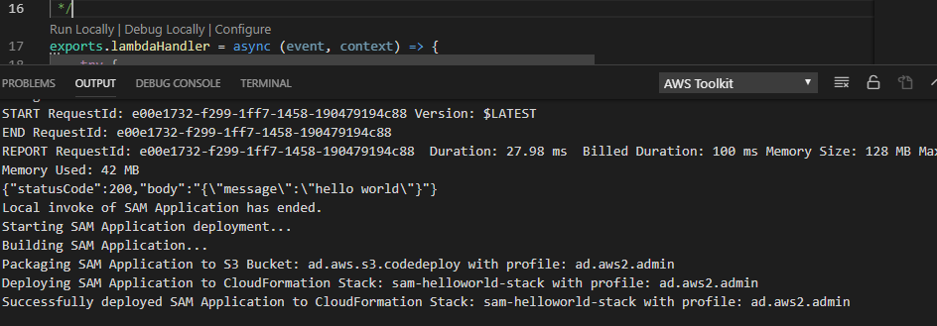
Figure SAM.VSC.3

Development Environment – Test SAM Locally

In order to aid and speed up development it is possible to configure a Serverless Application Model application to run locally for testing purposes. However to do that it is required to install Docker.
Initially I installed Docker Desktop. But this would not run unless a commercial licence for Windows Server exists. I had to uninstall Docker Desktop. I then installed Docker Toolbox [8]. I had numerous errors trying to deploy the SAM application locally on Docker. There were permissions issues, path problems, IDE configuration issues. It took 2 evenings to resolve all of the errors. However it is now possible for me to deploy and debug locally. Figure SAM.VSC.4
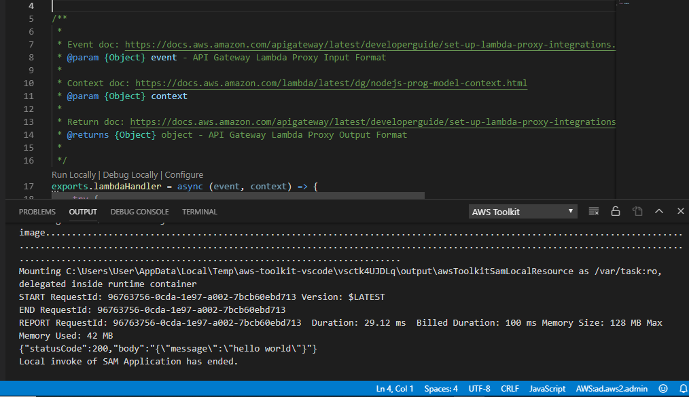
Figure SAM.VSC.4

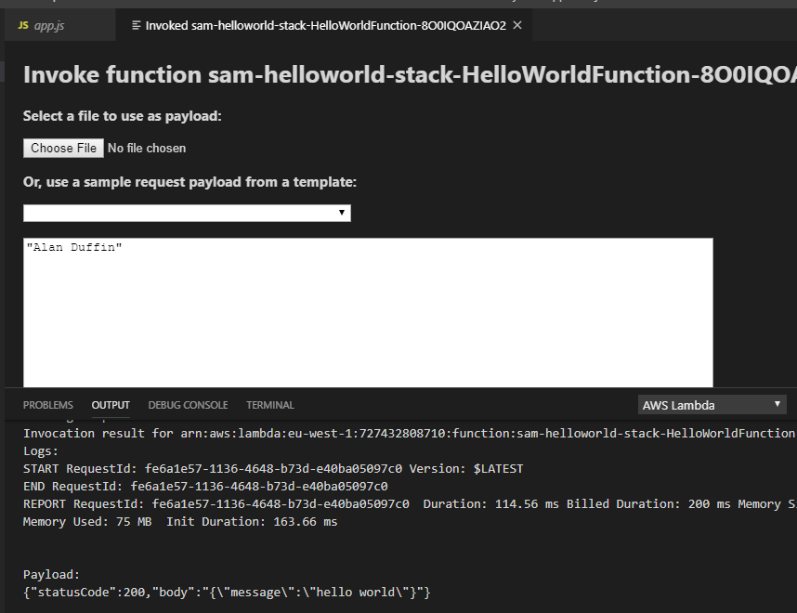
Figure SAM.VSC.5

Development – Build DynamoDB Stack

Cloudformation Stack link [9]. This CloudFormation template will create the tables listed in Figure DB.1.
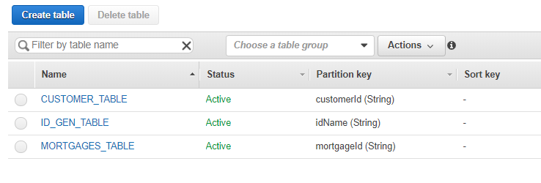
Figure DB.1

In order to create unique Identifiers for Customers and Mortgage applications I needed to create a table that would store a counter for the ids and allow atomic updates when new customers and mortgage applications are created. UUIDs would not be suitable for customer id or mortgage application numbers.

The ID_GEN_TABLE structure is shown in Figure DB.2
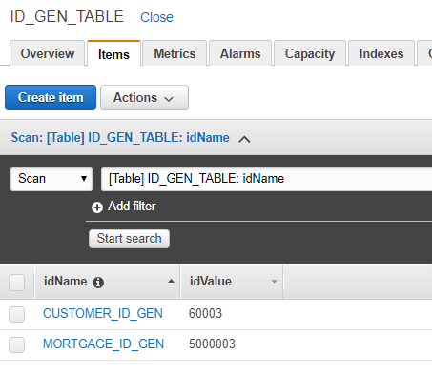
Figure DB.2

With regard to the Mortgages table, there is a requirement to allow application users to search all mortgage applications by the status code, e.g. 'PreSubmission' or 'In Assessment'. I tried a number of attempts to structure the table to achieve this but failed in the first 2 or 3 attempts. I had though originally that the statusCode should be a Range Key and make up part of a Composite primary key. However this does not provide the required access. When a table has a composite primary key then all getItem operations MUST contain both the Hash and Range key. However in this scenario we do not know both the Hash and Range key. So the solution was to create Secondary Global Indez which allows a different Hash Key that the main table. In this way we can use the getItem on the table when a single mortgage is required and we know the id. Then when seaching for all mortgages that currently have a particular status we can perform a query operation on the Index. Figure DB.3

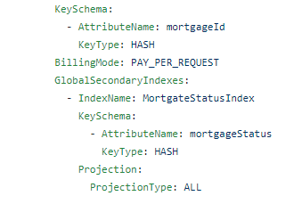

Figure DB.3

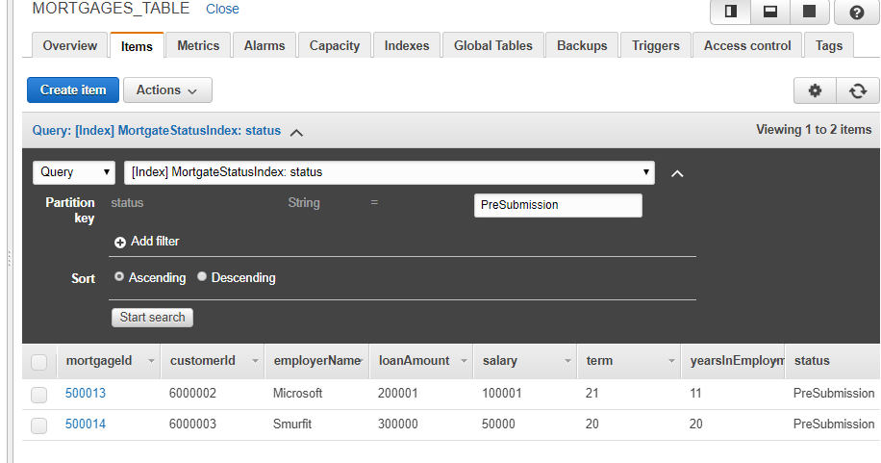
Figure DB.4

Development – Build Serverless Services – Lambda.

Cloudformation Stack link [10].
It has taken between 16-18 hours this week alone to get a small suite of HTTP services built, deployed and tested. There were many issues and problems to be worked through. There was the learning curve on the following areas:
1 How to properly structure Restful HTTP operations.
2 Learning how to work with NodeJS.
3 Learning the AWS Serverless Application Model framework concepts and syntax.
4 Once the basic service APIs were deployed, I then had to learn how to used the AWS SDK to integrate with DynamoDB. This took quite a long time to get even the simplest operations working. The DynamoDB operations have a complex set of required parameters and difficult syntax. See Figure LAMBDA.1
6 Understanding the Promise and asyn / await mechanisms for calling asynchronous AWS SDK operations also took time.

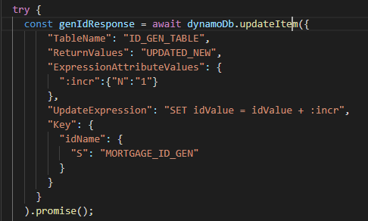
Figure LAMBDA.1

This figure illustrates the required query that is necessary to atomically read and increment a DynamoDB attribute.
Figure LAMBDA.2 illustrates the required operation structure for a simple update on the mortgage items.

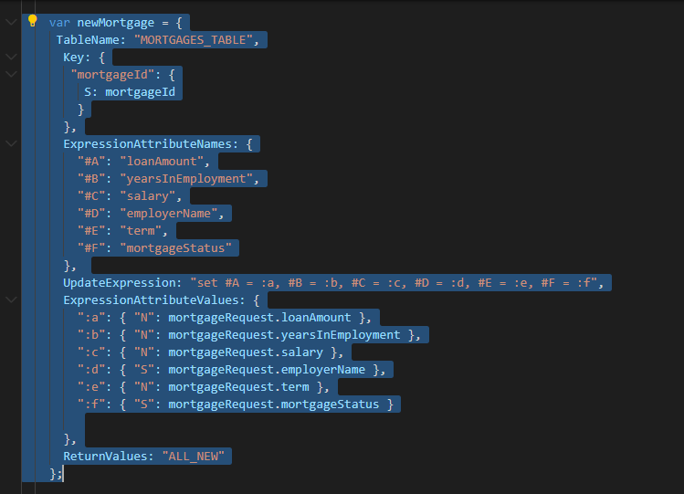
Figure LAMBDA.2

There were many errors encountered. A sample can be found illustrated in Figure LAMBDA.3 and LAMBDA.4

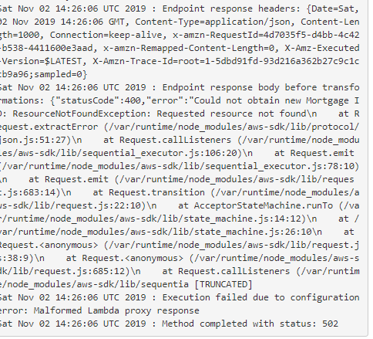
Figure LAMBDA.3

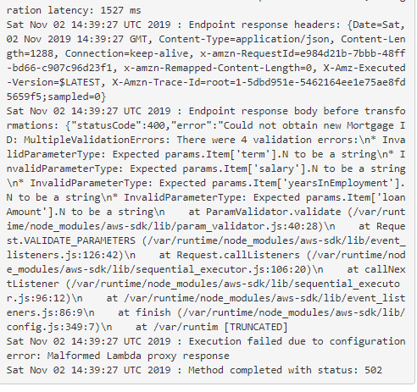
LAMBDA.4

The Lambda functions created so far are shown in Figure LAMBDA.5
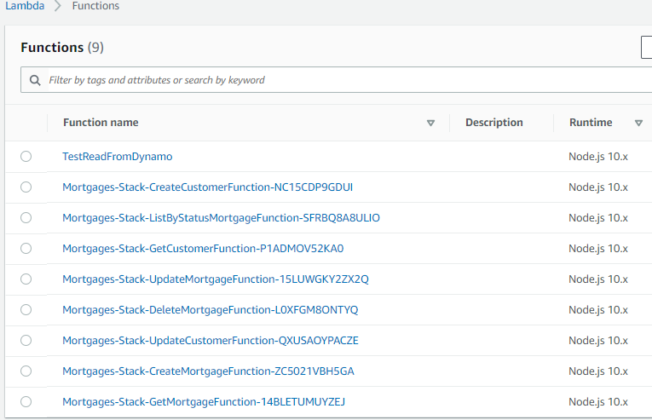
Figure LAMBDA.5

The API Gateway resource that have been create are listed in Figure LAMBDA.6

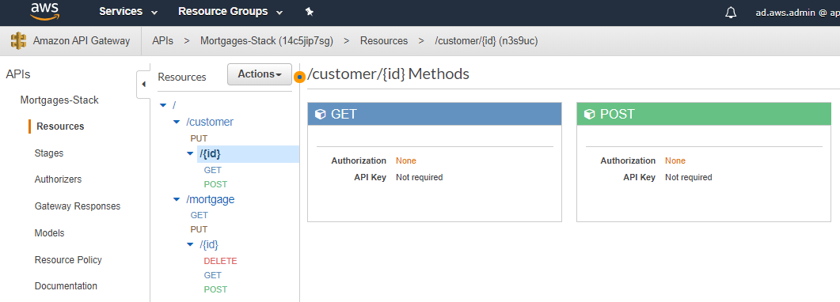
Figure LAMBDA.6

Development – Workflow Implmentation – Step Function.

The template for the inital implementation can be found at the link [11]. An illustration of the Step Function implementation is shown in Figure STEP.1.

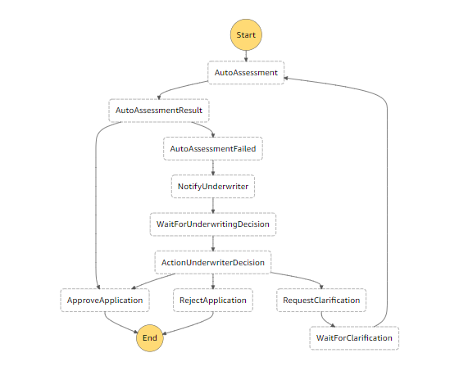
Figure STEP.1

Reference List and Bibliography

[1] AWS Free Tier. https://aws.amazon.com/free/
[2] AWS CLI. https://docs.aws.amazon.com/cli/latest/userguide/install-windows.html
[3] AWS CLI SAM. https://docs.aws.amazon.com/serverless-application-model/latest/developerguide/serverless-sam-cli-install-windows.html
[4] Node JS. https://nodejs.org/en/download/
[5] Configure AWS CLI. https://docs.aws.amazon.com/cli/latest/userguide/cli-chap-configure.html
[6] Visual Studio Code. https://code.visualstudio.com/download
[7] Configure AWS on Visual Studio Code. https://docs.aws.amazon.com/toolkit-for-vscode/latest/userguide/setup-toolkit.html
[8] Install Docker Toolbox. https://docs.docker.com/toolbox/toolbox_install_windows/
[9] DynamoDB Cloudformation Template. https://github.com/GeneralYeager/tallaght.mortgages/blob/master/mortgage.dynamo/dynamo-create.yml
[10] Lambda Cloudformation Template. https://github.com/GeneralYeager/tallaght.mortgages/blob/master/tud.mortgages/Tallaght-Mortgages-App/template.yaml
[11] Step Function State Machine Template. https://github.com/GeneralYeager/tallaght.mortgages/blob/master/mortgage.workflow/StateMachineV1.json

